
Patuakhali Science and Technology University
Faculty of Computer Science and Engineering

CCE 310 :: Software Development Project-I
Sessional Project Proposal

Submitted from,  Nazmus Sakib  ID : 2102066, Reg : 10193,  Semester : 5  (Level-3, Semester-1) | Submitted to,  - Prof. Dr. Md Samsuzzaman  Professor,  Department of Computer and Communication Engineering,  Patuakhali Science and Technology University.  - Arpita Howlader  Associate Professor,  Department of Computer and Communication Engineering,  Patuakhali Science and Technology University.

Project title: Medicore
Submission Date : Mon,21 July 2025

Contents
- Abstract ……………………………………………………………………………………2
- Objectives …………………………………………………………………………………2
- Problem Statement ……………………………………………………………………3
- Related work ……………………………………………………………………………..3
- Scope …………………………………………………………………………………………3
- Methodology ………………………………………………………………………………4
  - Technology Stack ……………………………………………………………..4
  - Design principles ……………………………………………………………..4
- Visual Models ………………………………………………………………………………4
  - Flow chart diagram …………………………………………………………….5
  - Entity Relationship Diagram (ERD)……………………………………..6
  - Timeline (Gantt Chart) ……………………………………………………….7
  - UI Mockups ………………………………………………………………………..9
- Limitations …………………………………………………………………………………….12
- Result …………………………………………………………………………………………….13
- Security and compliance………………………………………………………………….13
- Conclusion …………………………………………………………………………………….13

Project Proposal: Medicore - A Cross-Platform Medical Management Application

1. Abstract
Medicore is a cross-platform Flutter-based medical appointment and e-prescription app designed for both patients and doctors. It provides appointment scheduling, video consultations, digital prescriptions, and patient history tracking with integrated payment support for a seamless healthcare experience. In an age where efficient healthcare access and management are crucial, Medicore aims to provide a simplified and powerful interface to manage and retrieve valuable medical resources from anywhere.

2. Objectives
- Simplify appointment booking and management for patients and doctors.
- Enable secure e-prescription and comprehensive medical history tracking.
- Integrate secure payment options for online/offline consultation fees.
- Improve communication via in-app chat and real-time notifications.
- To offer a seamless, secure, and intuitive experience across Android, iOS, and potentially web platforms.

3. Problem Statement
Existing solutions for medical appointment and health record management are often fragmented, platform-specific, or lack comprehensive features. Patients frequently struggle with:
- Fragmented Medical Records: Health information scattered across multiple providers, clinics, and paper files, making it difficult to maintain a complete history.
- Inefficient Appointment Scheduling: Manual booking processes, long wait times, and difficulties in rescheduling or canceling appointments.
- Lack of Digital Prescriptions: Reliance on paper prescriptions, leading to potential loss, illegibility, and inefficiencies in refills.
- Limited Communication: Challenges in direct, secure communication between patients and doctors outside of consultations.
- Payment Hurdles: Inconvenient payment methods for consultations, often requiring physical presence.
There is a clear need for a comprehensive, user-friendly tool that centralizes medical management, streamlines processes, and enhances communication for both patients and healthcare providers.

4. Related Work
Several existing applications address parts of the medical management ecosystem, but often lack a unified approach or specific features:
- Telehealth Platforms: Offer video consultations but may lack robust personal health record management or e-prescription capabilities.
- Hospital/Clinic-Specific Apps: Often tied to a single healthcare provider, limiting comprehensive management across multiple doctors.
- Medication Reminder Apps: Focus solely on medication adherence, without integrating appointments or records.
- Personal Health Record Apps: May allow record storage but lack direct appointment booking or consultation features.
Medicore aims to address these limitations by offering a more comprehensive, integrated, and user-centric solution.

5. Scope
Medicore will be developed as a cross-platform application using Flutter, allowing it to run on Android, iOS, and potentially web browsers. The initial version will focus on providing a rich set of features for managing appointments, e-prescriptions, and medical records. It will also include secure user authentication, role-based dashboards, and integrated payment processing.
Later on, it can be extended to include advanced features like integration with wearable health devices, AI-powered symptom analysis, deeper EHR integrations, and more sophisticated analytics for both patients and doctors.

6. Methodology
The development of Medicore will follow an agile methodology, allowing for iterative improvements and user feedback.

6.1. Technology Stack
- Frontend: Flutter (Dart) for cross-platform mobile development.
- Backend: Firebase (for authentication, real-time database, cloud functions) and/or PHP + MySQL (for custom logic and relational data).
- Database: Firestore (for NoSQL flexibility with Firebase) or MySQL (for structured relational data).
- Payment Gateway: SSLCommerz for secure and localized payment processing.
- Notifications: Firebase Cloud Messaging (FCM) for real-time alerts and reminders.
- UI/UX Design: Figma for wireframing, mockups, and interactive prototypes.

6.2. Design Principles
The design of Medicore will adhere to the following principles:
- User-Centric Design: Focusing on intuitive navigation, clear UI elements, and ease of use for diverse user groups (patients, doctors, admins).
- Material Design / Cupertino Design: Following platform-specific guidelines for a consistent and modern UI/UX on Android and iOS, respectively.
- Responsive Design: Ensuring the application works seamlessly on various screen sizes and orientations.
- Security & Privacy by Design: Integrating robust security measures and adhering to healthcare data privacy regulations from the outset.
- Accessibility: Designing for users with varying abilities, including considerations for screen readers, font sizing, and clear visual hierarchies.

7. Visual Models
This section provides conceptual descriptions of the essential visual and structural models that would underpin the "Medicore" application's design and development. As an AI, I cannot generate actual visual diagrams or interactive UI mockups, but these descriptions serve as blueprints.

7.1. Flow Chart Diagram

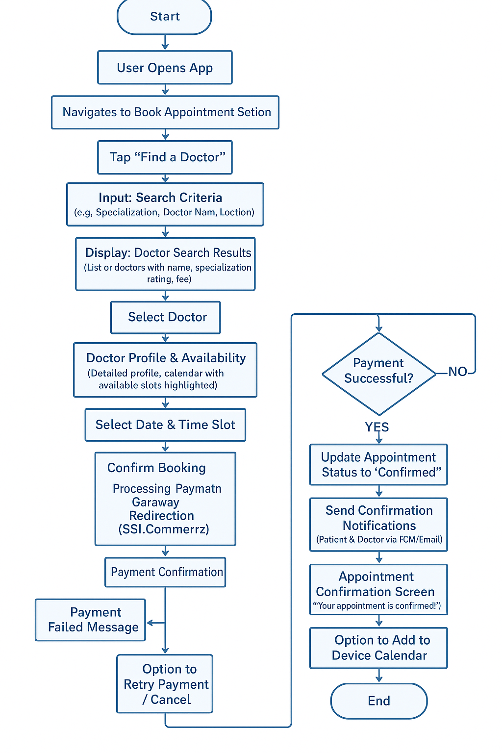

7.2. Entity Relationship (ER) Diagram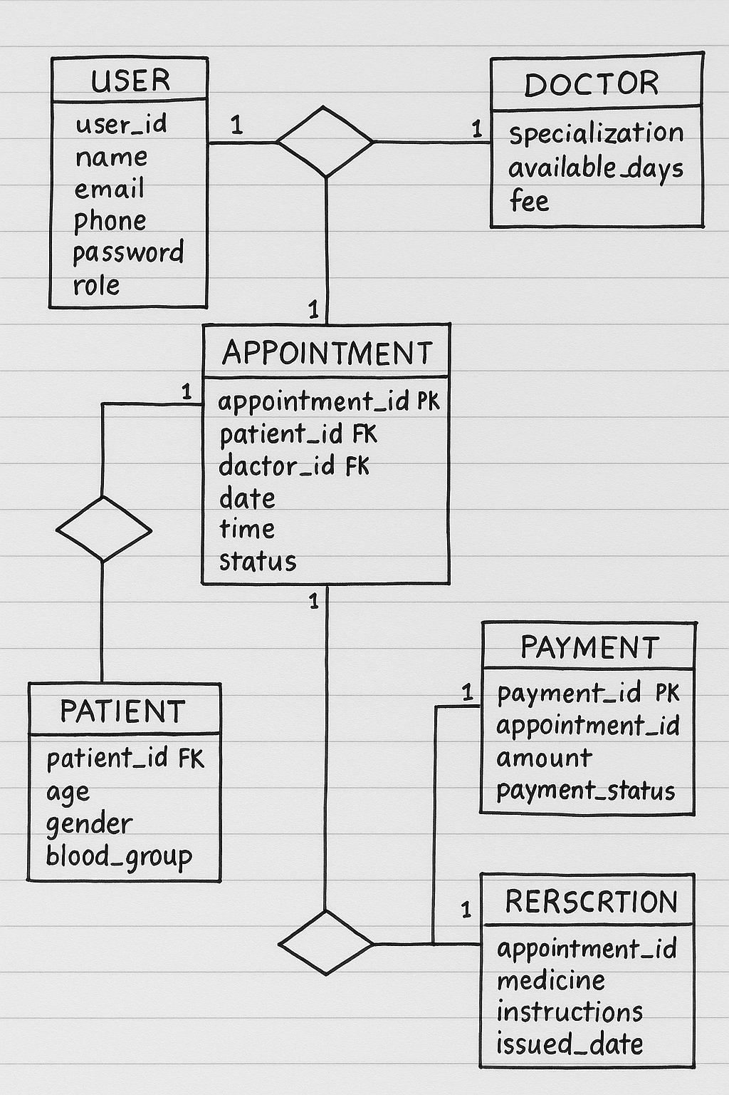
  - .

7.3. Timeline (Gantt Chart)
Phase | Task Name | Duration (Weeks) | Dependencies | Milestones
Phase 1: Discovery & Planning
 | 1.1 Requirements Gathering | 2 | - | Requirements Sign-off
 | 1.2 Technical Architecture Design | 3 | 1.1 | Architecture Approved
Phase 2: UI/UX Design & Prototyping
 | 2.1 Wireframing & User Flows | 2 | 1.2 | Wireframes Approved
 | 2.2 High-Fidelity UI Design | 4 | 2.1 | UI Designs Approved
 | 2.3 Interactive Prototyping | 3 | 2.2 | Prototype Ready
Phase 3: Core MVP Development
 | 3.1 Backend & API Development | 12 | 1.2 | Backend Alpha
 | 3.2 Frontend Dev (Auth, Dashboards) | 6 | 2.3, 3.1 (start) | User Auth Ready
 | 3.3 Frontend Dev (Doc Listing, Appt Booking) | 8 | 3.2, 3.1 (progress) | Booking Flow Ready
 | 3.4 Frontend Dev (E-Prescription, Records) | 6 | 3.3, 3.1 (progress) | Core Features Ready
 | 3.5 Payment Gateway Integration | 4 | 3.1, 3.3 | Payments Integrated
 | 3.6 Notifications Integration | 2 | 3.1, 3.3 | Notifications Live
Phase 4: Testing & Quality Assurance
 | 4.1 Functional & Integration Testing | 4 | 3.6 | QA Cycle 1 Complete
 | 4.2 Security & Performance Testing | 3 | 4.1 | Security Audit
 | 4.3 Bug Fixing & Refinement | 3 | 4.1, 4.2 | UAT Ready
 | 4.4 User Acceptance Testing (UAT) | 2 | 4.3 | UAT Sign-off
Phase 5: Deployment & Launch
 | 5.1 App Store Submission | 2 | 4.4 | App Live
 | 5.2 Initial Marketing & PR | 3 | 4.4 (parallel) | Launch Campaign
Phase 6: Post-Launch & Iteration
 | 6.1 Monitoring & Support | Ongoing | 5.1 | Continuous
 | 6.2 Feature Enhancements (v1.1, etc.) | Ongoing | User Feedback & Analytics | Updates Released

7.4. UI Mockups

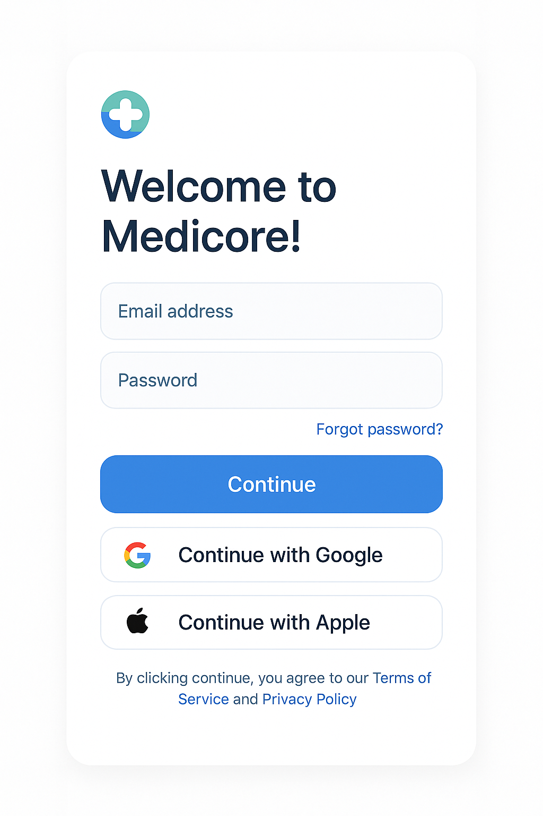

Fig: UI Mockups Loging page
  - 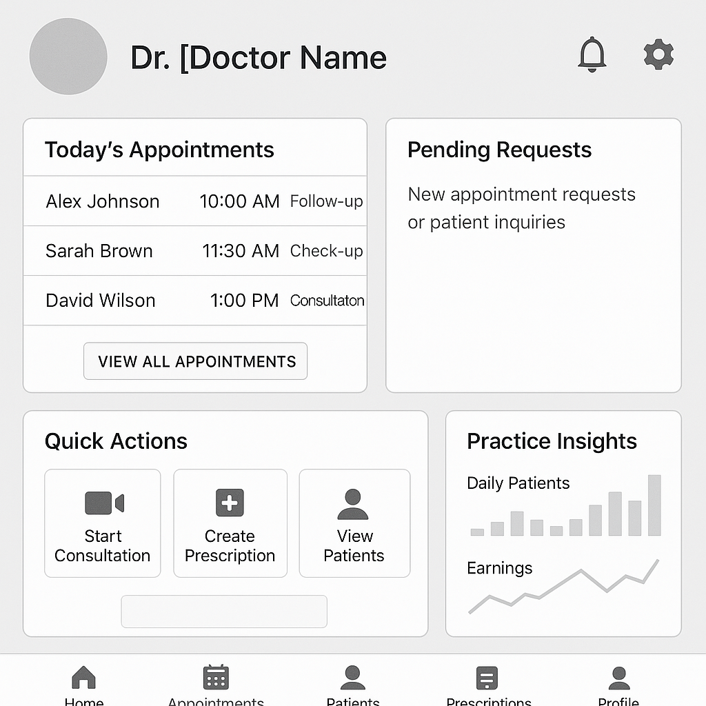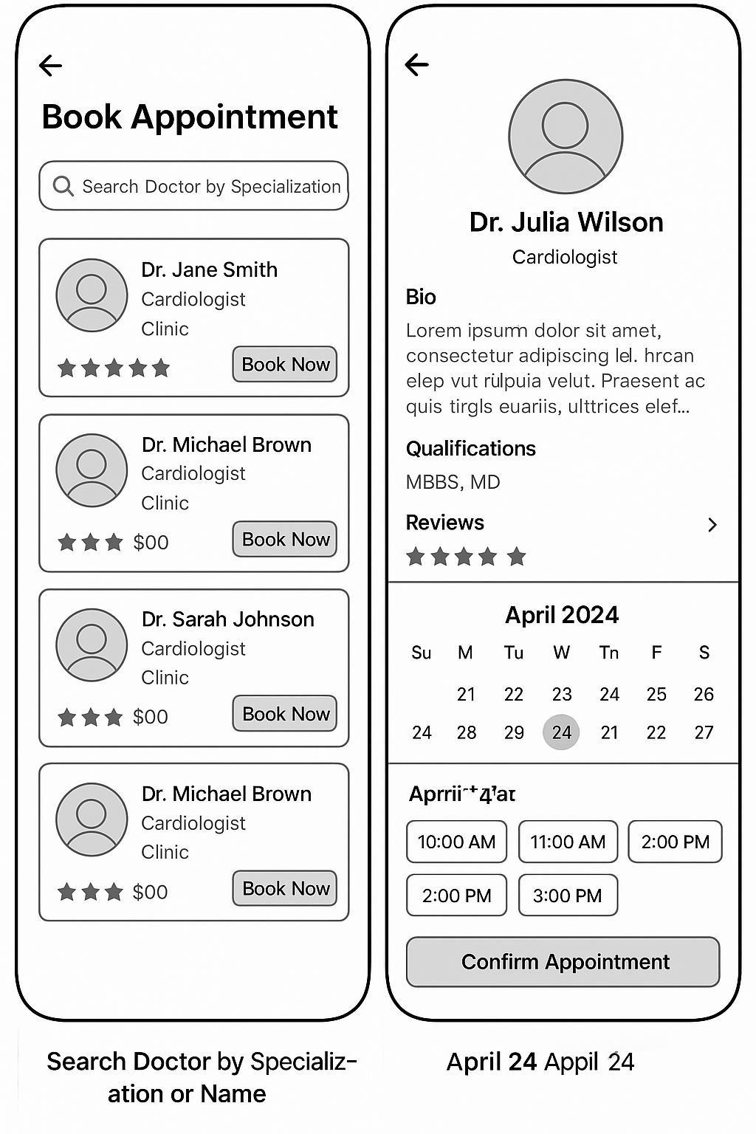

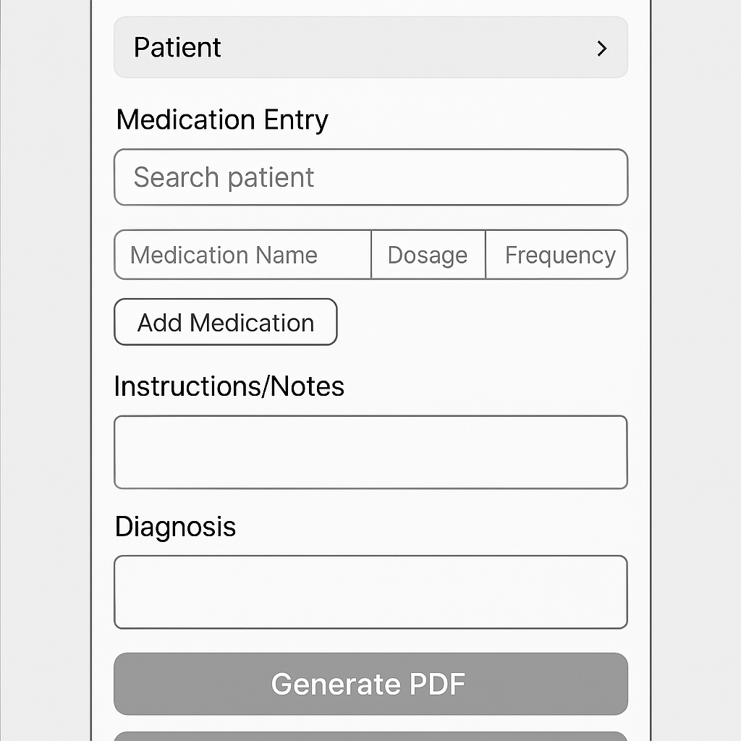8. Limitations
- Browser Extensions: Currently, browser extensions are not planned, but the application will be designed to allow easy integration with popular browsers in the future for potential web-based access.
- Initial Feature Set: The initial version will focus on core functionalities (appointment, e-prescription, basic records, payments) and may not include all advanced features like deep EHR integration, AI diagnostics, or comprehensive wearable device syncing. These will be considered for future iterations.
- Offline Functionality: While core data will be synced, extensive offline capabilities (e.g., full medical record access without internet) might be limited in the initial MVP.

9. Result
The expected outcome of Medicore is a fully functional, secure, and cross-platform application that allows users to manage their personal healthcare efficiently and empowers doctors to streamline their practice. It aims to improve patient engagement, reduce administrative burdens, and foster better communication within the healthcare ecosystem.

10. Security and Compliance
Given the sensitive nature of medical data, security and compliance will be paramount throughout the development lifecycle. This includes:
- Data Encryption: Implementing robust encryption for data at rest and in transit (e.g., SSL/TLS for communication, database encryption).
- Authentication & Authorization: Strong user authentication mechanisms (e.g., Firebase Email OTP, multi-factor authentication) and granular role-based access control to ensure users only access data relevant to their role.
- Regular Security Audits: Conducting periodic security assessments, vulnerability scanning, and penetration testing by third-party experts.
- Regulatory Adherence: Ensuring strict compliance with relevant healthcare data privacy regulations such as HIPAA (for the US market), GDPR (for the EU market), and local data protection laws in Bangladesh. Legal consultation will be sought to ensure full adherence.
- Secure API Design: Implementing secure API endpoints with proper input validation, rate limiting, and secure token management to prevent unauthorized access and data breaches.
- Audit Trails: Maintaining comprehensive audit logs for all data access and modification activities.

11. Conclusion
Medicore aims to be a transformative digital solution for personal healthcare management. By combining a user-friendly interface built with Flutter, a robust backend, and essential features like appointment booking, e-prescriptions, and payment integration, it will empower patients and streamline operations for doctors. Our unwavering commitment to security and compliance will ensure a trustworthy platform, making Medicore an indispensable tool for a more connected, efficient, and patient-centric healthcare ecosystem.

